- Open your own laptop or desktop (or use an online PC hardware simulator if you don't have access to a real system) and identify the GPU model installed. Write down the GPU's brand, model number, and whether it is integrated or dedicated.

Answer :-

GPU Brand:- NVIDIA
GPU Model:- GeForce RTX 2050 Laptop GPU
GPU Type:- Dedicated Graphics

- Take a clear photo or screenshot of the cooling system (fan, heatsink, or liquid cooling setup) inside your PC or from a PC hardware simulator. Label the main cooling components and briefly describe their function.
Answer :-

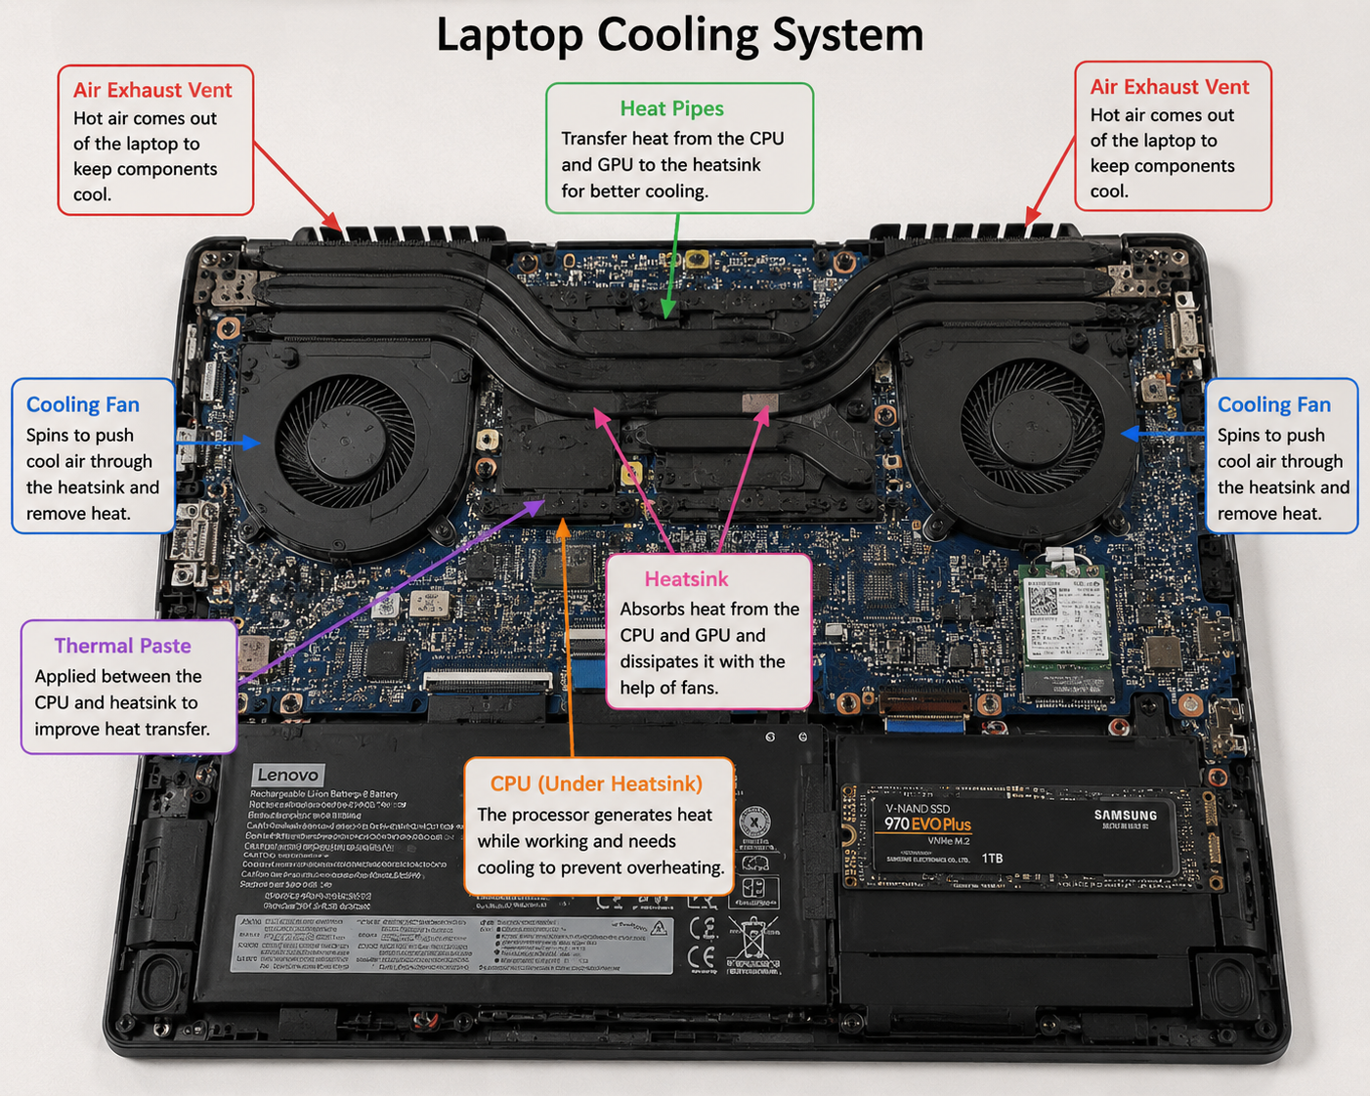

- Create a comparison table listing at least 3 differences between air cooling and liquid cooling systems for GPUs, including factors like cost, efficiency, and maintenance.
Answer :-
Comparison Table: Air Cooling vs Liquid Cooling for GPUs
Feature | Air Cooling | Liquid Cooling
Colling Method | Uses heatsinks and fans to dissipate heat. | Uses coolant, water blocks, radiator, and pump to remove heat.
Cooling Efficiency | Good for normal gaming and everyday use. | Excellent for high-performance gaming, overclocking, and heavy workloads.
Cost | Lower cost and more affordable. | Higher cost due to additional cooling components.
Maintenance | Very little maintenance; occasional dust cleaning is enough. | Requires regular maintenance, such as checking coolant levels and cleaning the radiator.
Noise Level | Can become noisy when fans run at high speed. | Usually quieter because fans can run at lower speeds.
Installation | Easy to install and suitable for most users. | More complex installation with radiator, tubing, and pump.
Best Use Case | Office PCs, budget gaming PCs, and everyday users. | High-end gaming PCs, professional workstations, and overclocked systems.

- Imagine you are building a gaming PC for streaming IPL matches and playing graphics -heavy games. Choose between air cooling and liquid cooling for your GPU and justify your choice in 3-4 sentences based on your research.
Answer :-
I would choose liquid cooling for my GPU because it provides better cooling performance during long gaming and streaming sessions. Graphics-intensive games and streaming IPL matches at the same time can generate a lot of heat, and liquid cooling helps maintain lower GPU temperatures. It also operates more quietly than air cooling under heavy workloads. Although it is more expensive and requires more maintenance, the improved performance and stability make it the better choice for a high-end gaming PC.

